AutoEmail Full Installation Tests
Tester: Tony Tasker
Date: 19th January 2017
Time: 11:20
PC/Server: TonyTasker-PC\SQL2014STD
Database: Simmons_V7_Test (Copy of Simmons and Simmons Live DB)
Works Summary: N/A
Works Order: N/A
Task: N/A
Notes:

Pre-Test Setup
No | Task | Tester | Pass | Notes
1 | Get Access to CABS DB without AutoEMail Functionality | TT |  | Restored DB to Simmons_V7_Test
2 | Copy all scripts to run to an installation directory | TT |  | Used C:\Users\tony.tasker\Documents\Temp\AutoEmailSQL
3 | Amended scripts:  - 18. Auto-Emailer Session Check.sql  - 19. Auto-Emailer Recurring Emails Check.sql  - 20. Auto-Emailer AEF_LINK Delete.sql  to include DB name and DB Login | TT |  | SET @DBName = N‘Simmons_V7_Test’  SET @DBLogin = N'cc'
4 | Amended script:  - AutoEMail_Install.sql  To include DB Server Name, DB Name and Path to the scripts directory | TT |  | DECLARE @DBServerName VARCHAR(100) = 'TonyTasker-PC\SQL2014STD'  DECLARE @DBName VARCHAR(100) = 'Simmons_V7_Test  DECLARE @Path VARCHAR(500) = ' C:\Users\tony.tasker\Documents\Temp\AutoEmailSQL \'

Post-Test Setup
No | Task | Tester | Pass | Notes
1 | N/A

Tests

Install AutoEMail Using Install Script
No | Test | Tester | Pass | Notes
1 | In SQL Server Management Studio open script SSMiscReqs.sql and execute it | TT |  | Step not normally needed as part of AutoEmail installation but mitigates missing SQL objects from DB
1 | In SQL Server Management Studio open script AutoEmail_Install.sql and execute it | TT
2 | Review the Results Pane for any Errors | TT

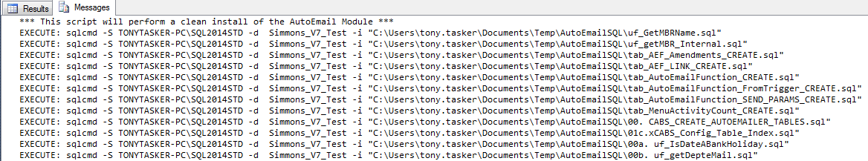
Figure 1 - Installation Messages

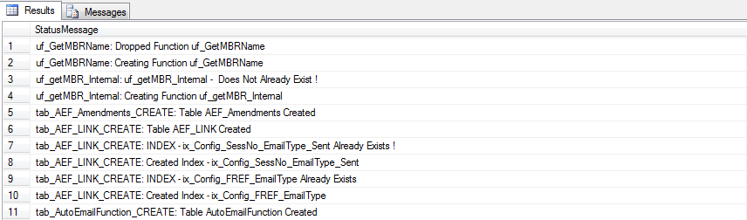
Figure 2 – Installation Results
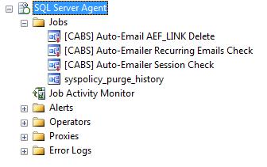
Figure 3 – New SQL Agent Jobs

Configure AutoEMail
No | Test | Tester | Pass | Notes
1 | In SQL Server Management Studio open script Simmons and Simmons Configuration.sql and execute it | TT
2 | Check System Default Settings | TT |  | Sections AEFCON, CABS_AUTO_EMAIL_FUNCS, CABS_AUTO_EMAIL_FUNCS_Trigger and DeptEmailAddresses all created

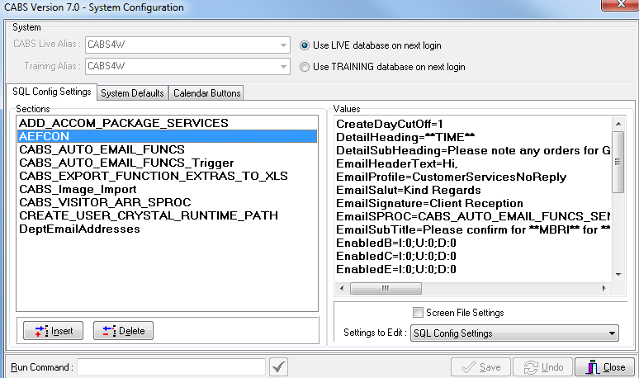
Figure 4 - AutoEmail Configuration

Installation Messages
StatusMessage
uf_GetMBRName: Dropped Function uf_GetMBRName
uf_GetMBRName: Creating Function uf_GetMBRName
uf_getMBR_Internal: uf_getMBR_Internal - Does Not Already Exist !
uf_getMBR_Internal: Creating Function uf_getMBR_Internal
tab_AEF_Amendments_CREATE: Table AEF_Amendments Created
tab_AEF_LINK_CREATE: Table AEF_LINK Created
tab_AEF_LINK_CREATE: INDEX - ix_Config_SessNo_EmailType_Sent Already Exists !
tab_AEF_LINK_CREATE: Created Index - ix_Config_SessNo_EmailType_Sent
tab_AEF_LINK_CREATE: INDEX - ix_Config_FREF_EmailType Already Exists
tab_AEF_LINK_CREATE: Created Index - ix_Config_FREF_EmailType
tab_AutoEmailFunction_CREATE: Table AutoEmailFunction Created
tab_AutoEmailFunction_FromTrigger_CREATE: Table AutoEmailFunction_FromTrigger Created
tab_AutoEmailFunction_SEND_PARAMS_CREATE: Table AutoEmailFunction_SEND_PARAMS Created
tab_MenuActivityCount_CREATE: Table MenuActivityCount Created
00. CABS_CREATE_AUTOEMAILER_TABLES: Dropped Procedure CABS_CREATE_AUTOEMAILER_TABLES
00. CABS_CREATE_AUTOEMAILER_TABLES: Creating Procedure CABS_CREATE_AUTOEMAILER_TABLES
00. CABS_CREATE_AUTOEMAILER_TABLES: Executing Procedure CABS_CREATE_AUTOEMAILER_TABLES
01c.xCABS_Config_Table_Index: INDEX ix_Config_Type_Section_Deleted ON [dbo].[xCABS_CONFIG_TABLE] Does Not Exist !
01c.xCABS_Config_Table_Index: Creating INDEX ix_Config_Type_Section_Deleted ON [dbo].[xCABS_CONFIG_TABLE]
01c.xCABS_Config_Table_Index: INDEX ix_Config_Type_Section_Key_Deleted ON [dbo].[xCABS_CONFIG_TABLE] Does Not Exist !
01c.xCABS_Config_Table_Index: Creating INDEX INDEX ix_Config_Type_Section_Key_Deleted ON [dbo].[xCABS_CONFIG_TABLE]
00a. uf_IsDateABankHoliday: Dropped Function uf_IsDateABankHoliday
00a. uf_IsDateABankHoliday: Creating Function uf_IsDateABankHoliday
00b. uf_getDepteMail: uf_getDepteMail - Does Not Already Exist !
00b. uf_getDepteMail: Creating Function uf_getDepteMail
00c. uf_HasRoomBeenGiven: uf_HasRoomBeenGiven - Does Not Already Exist !
00c. uf_HasRoomBeenGiven: Creating Function uf_HasRoomBeenGiven
00d. uf_CreateDateDiff: uf_CreateDateDiff - Does Not Already Exist !
00d. uf_CreateDateDiff: Creating Function uf_CreateDateDiff
00e. uf_getDeptCodes: uf_getDeptCodes - Does Not Already Exist !
00e. uf_getDeptCodes: Creating Function uf_getDeptCodes
00f. uf_getFunctionDeptEmails: uf_getFunctionDeptEmails - Does Not Already Exist !
00f. uf_getFunctionDeptEmails: Creating Function uf_getFunctionDeptEmails
00g. fn_GetEnabledValue: fn_GetEnabledValue - Does Not Already Exist !
00g. fn_GetEnabledValue: Creating Function fn_GetEnabledValue
00h. fn_GetHiddenRoomText: Dropped Function fn_GetHiddenRoomText
00h. fn_GetHiddenRoomText: Creating Function fn_GetHiddenRoomText
00i. fn_GetMinsValue: Dropped Function fn_GetMinsValue
00i. fn_GetMinsValue: Creating Function fn_GetMinsValue
00j. fn_GetTimeValue: Dropped Function fn_GetTimeValue
00j. fn_GetTimeValue: Creating Function fn_GetTimeValue
00k. fnGet_Config_Value: Dropped Function fnGet_Config_Value
00k. fnGet_Config_Value: Creating Function fnGet_Config_Value
00l. uf_IsSendableSessBooking: uf_IsSendableSessBooking - Does Not Already Exist !
00l. uf_IsSendableSessBooking: Creating Function uf_IsSendableSessBooking
00m. uf_GetEmailEarlyCutOff: uf_GetEmailEarlyCutOff - Does Not Already Exist !
00m. uf_GetEmailEarlyCutOff: Creating Function uf_GetEmailEarlyCutOff
00n. uf_getExtraDescription: uf_getExtraDescription - Does Not Already Exist !
00n. uf_getExtraDescription: Creating Function uf_getExtraDescription
00o. uf_getMenuItemDescription: uf_getMenuItemDescription - Does Not Already Exist !
00o. uf_getMenuItemDescription: Creating Function uf_getMenuItemDescription
00p. utf_DrinkTrolleyView: utf_DrinkTrolleyView - Does Not Already Exist !
00p. utf_DrinkTrolleyView: Creating Function utf_DrinkTrolleyView
00q. utf_MenuView: utf_MenuView - Does Not Already Exist !
00q. utf_MenuView: Creating Function utf_MenuView
00r. utf_PackageView: utf_PackageView - Does Not Already Exist !
00r. utf_PackageView: Creating Function utf_PackageView
00s. uf_GetMenuItemCount: uf_GetMenuItemCount - Does Not Already Exist !
00s. uf_GetMenuItemCount: Creating Function uf_GetMenuItemCount
02. uf_AEF_Link_Sendable: uf_AEF_Link_Sendable - Does Not Already Exist !
02. uf_AEF_Link_Sendable: Creating Function uf_AEF_Link_Sendable
03. uf_GetEmailSendTime: Dropped Function uf_GetEmailSendTime
03. uf_GetEmailSendTime: Creating Function uf_GetEmailSendTime
04. uf_GetEmailSendType: uf_GetEmailSendType - Does Not Already Exist !
04. uf_GetEmailSendType: Creating Function uf_GetEmailSendType
04a.uf_Get_FirstName_From_CT_DESC: uf_Get_FirstName_From_CT_DESC - Does Not Already Exist !
04a.uf_Get_FirstName_From_CT_DESC: Creating Function uf_Get_FirstName_From_CT_DESC
04b.uf_Get_LastName_From_CT_DESC: uf_Get_LastName_From_CT_DESC - Does Not Already Exist !
04b.uf_Get_LastName_From_CT_DESC: Creating Function uf_Get_LastName_From_CT_DESC
04c.uf_Get_TelNo_From_CT_DESC: uf_Get_TelNo_From_CT_DESC - Does Not Already Exist !
04c.uf_Get_TelNo_From_CT_DESC: Creating Function uf_Get_TelNo_From_CT_DESC
04d.uf_Get_EC_Email: uf_Get_EC_Email - Does Not Already Exist !
04d.uf_Get_EC_Email: Creating Function uf_Get_EC_Email
04e.uf_Get_Acc_Man_Email: uf_Get_Acc_Man_Email - Does Not Already Exist !
04e.uf_Get_Acc_Man_Email: Creating Function uf_Get_Acc_Man_Email
04e.uf_Get_Acc_Man_FirstName: uf_Get_Acc_Man_FirstName - Does Not Already Exist !
04e.uf_Get_Acc_Man_FirstName: Creating Function uf_Get_Acc_Man_FirstName
04e.uf_Get_Acc_Man_LastName: uf_Get_Acc_Man_LastName - Does Not Already Exist !
04e.uf_Get_Acc_Man_LastName: Creating Function uf_Get_Acc_Man_LastName
04e.uf_Get_Acc_Man_Telephone: uf_Get_Acc_Man_Telephone - Does Not Already Exist !
04e.uf_Get_Acc_Man_Telephone: Creating Function uf_Get_Acc_Man_Telephone
04e.uf_Get_EC_LastName: uf_Get_EC_LastName - Does Not Already Exist !
04e.uf_Get_EC_LastName: Creating Function uf_Get_EC_LastName
04e.uf_Get_EC_Telephone: uf_Get_EC_Telephone - Does Not Already Exist !
04e.uf_Get_EC_Telephone: Creating Function uf_Get_EC_Telephone
04f.uf_Get_EC_FirstName: uf_Get_EC_FirstName - Does Not Already Exist !
04f.uf_Get_EC_FirstName: Creating Function uf_Get_EC_FirstName
05. ufAEF_MatchCriteria: ufAEF_MatchCriteria - Does Not Already Exist !
05. ufAEF_MatchCriteria: Creating Function ufAEF_MatchCriteria
uf_AEF_Is_Within_Send_Window: uf_AEF_Is_Within_Send_Window - Does Not Already Exist !
uf_AEF_Is_Within_Send_Window: Creating Function uf_AEF_Is_Within_Send_Window
06.uf_Get_AEF_EnabledSwitch: uf_Get_AEF_EnabledSwitch - Does Not Already Exist !
06.uf_Get_AEF_EnabledSwitch: Creating Function uf_Get_AEF_EnabledSwitch
06. vw_AEFLink: View vw_AEFLink Does Not Exist !
06. vw_AEFLink: Creating View vw_AEFLink
06a. vw_Extras: Dropped View vw_Extras
06a. vw_Extras: Creating View vw_Extras
06b. vw_PackCodeDept: View vw_PackCodeDept Does Not Exist !
06b. vw_PackCodeDept: Creating View vw_PackCodeDept
06c. vw_Packages: View vw_Packages Does Not Exist !
06c. vw_Packages: Creating View vw_Packages
06d. vw_Menus: View vw_Menus Does Not Exist !
06d. vw_Menus: Creating View vw_Menus
06e. vw_DTCodeDept: View vw_DTCodeDept Does Not Exist !
06e. vw_DTCodeDept: Creating View vw_DTCodeDept
06f. vw_DrinkTrolley: View vw_DrinkTrolley Does Not Exist !
06f. vw_DrinkTrolley: Creating View vw_DrinkTrolley
06g. vw_ExtraCodeDept: View vw_ExtraCodeDept Does Not Exist !
06g. vw_ExtraCodeDept: Creating View vw_ExtraCodeDept
06h. vw_FunctionCostCentres: View vw_FunctionCostCentres Does Not Exist !
06h. vw_FunctionCostCentres: Creating View vw_FunctionCostCentres
06i. vw_ExtrasAmendDel: View vw_ExtrasAmendDel Does Not Exist !
06i. vw_ExtrasAmendDel: Creating View vw_ExtrasAmendDel
00a. sp_ae_DEL_AEF_Amendments: ae_DEL_AEF_Amendments - Does Not Already Exist !
00a. sp_ae_DEL_AEF_Amendments: Creating Procedure ae_DEL_AEF_Amendments
00b. sp_CABS_CREATE_BOOKING_UPDATE_TABLES: CABS_CREATE_BOOKING_UPDATE_TABLES - Does Not Already Exist !
00b. sp_CABS_CREATE_BOOKING_UPDATE_TABLES: Creating Procedure CABS_CREATE_BOOKING_UPDATE_TABLES
00c. sp_CABS_AUTO_BOOKING_UPDATE: CABS_AUTO_BOOKING_UPDATE - Does Not Already Exist !
00c. sp_CABS_AUTO_BOOKING_UPDATE: Creating Procedure CABS_AUTO_BOOKING_UPDATE
00d. sp_ae_UPD_AEF_Amendments: ae_UPD_AEF_Amendments - Does Not Already Exist !
00d. sp_ae_UPD_AEF_Amendments: Creating Procedure ae_UPD_AEF_Amendments
00e. ae_INS_AEF_Amendments: ae_INS_AEF_Amendments - Does Not Already Exist !
00e. ae_INS_AEF_Amendments: Creating Procedure ae_INS_AEF_Amendments
07. ae_INS_EmailTypes_AEF_Link: ae_INS_EmailTypes_AEF_Link - Does Not Already Exist !
07. ae_INS_EmailTypes_AEF_Link: Creating Procedure ae_INS_EmailTypes_AEF_Link
00f. spAutoEmail_MenuItems: spAutoEmail_MenuItems - Does Not Already Exist !
00f. spAutoEmail_MenuItems: Creating Procedure spAutoEmail_MenuItems
07a. ae_INS_EmailTypes_AEF_Link_MBR: ae_INS_EmailTypes_AEF_Link_MBR - Does Not Already Exist !
07a. ae_INS_EmailTypes_AEF_Link_MBR: Creating Procedure ae_INS_EmailTypes_AEF_Link_MBR
08. CABS_AEF_RESET_AEFL_SENT: CABS_AEF_RESET_AEFL_SENT - Does Not Already Exist !
08. CABS_AEF_RESET_AEFL_SENT: Creating Procedure CABS_AEF_RESET_AEFL_SENT
08a. CABS_AEF_DELETE_RECORDS: CABS_AEF_DELETE_RECORDS - Does Not Already Exist !
08a. CABS_AEF_DELETE_RECORDS: Creating Procedure CABS_AEF_DELETE_RECORDS
09. CABS_AEF_SEND_CHN: CABS_AEF_SEND_CHN - Does Not Already Exist !
09. CABS_AEF_SEND_CHN: Creating Procedure CABS_AEF_SEND_CHN
10. CABS_AEF_SEND_CXL: CABS_AEF_SEND_CXL - Does Not Already Exist !
10. CABS_AEF_SEND_CXL: Creating Procedure CABS_AEF_SEND_CXL
11. CABS_AEF_SEND_PRQ: CABS_AEF_SEND_PRQ - Does Not Already Exist !
11. CABS_AEF_SEND_PRQ: Creating Procedure CABS_AEF_SEND_PRQ
11b. CABS_AEF_SEND_DOB: CABS_AEF_SEND_DOB - Does Not Already Exist !
11b. CABS_AEF_SEND_DOB: Creating Procedure CABS_AEF_SEND_DOB
12. CABS_AEF_SEND_UIE: CABS_AEF_SEND_UIE - Does Not Already Exist !
12. CABS_AEF_SEND_UIE: Creating Procedure CABS_AEF_SEND_UIE
13. CABS_AEF_SEND_UPE: CABS_AEF_SEND_UPE - Does Not Already Exist !
13. CABS_AEF_SEND_UPE: Creating Procedure CABS_AEF_SEND_UPE
14. CABS_AUTO_EMAIL_FUNCS_SEND: Dropped Procedure CABS_AUTO_EMAIL_FUNCS_SEND
14. CABS_AUTO_EMAIL_FUNCS_SEND: Creating Procedure CABS_AUTO_EMAIL_FUNCS_SEND
14a. CABS_AEF_SEND_SFD: CABS_AEF_SEND_SFD - Does Not Already Exist !
14a. CABS_AEF_SEND_SFD: Creating Procedure CABS_AEF_SEND_SFD
15. CABS_AUTO_EMAIL_FUNCS: Dropped Procedure CABS_AUTO_EMAIL_FUNCS
15. CABS_AUTO_EMAIL_FUNCS: Creating Procedure CABS_AUTO_EMAIL_FUNCS
16. CABS_AUTO_EMAIL_FUNCS_SESS_CHECK: CABS_AUTO_EMAIL_FUNCS_SESS_CHECK - Does Not Already Exist !
16. CABS_AUTO_EMAIL_FUNCS_SESS_CHECK: Creating Procedure CABS_AUTO_EMAIL_FUNCS_SESS_CHECK
16a. CABS_AEF_SEND_ECC: CABS_AEF_SEND_ECC - Does Not Already Exist !
16a. CABS_AEF_SEND_ECC: Creating Procedure CABS_AEF_SEND_ECC
16b. CABS_AEF_SEND_FFC: CABS_AEF_SEND_FFC - Does Not Already Exist !
16b. CABS_AEF_SEND_FFC: Creating Procedure CABS_AEF_SEND_FFC
17. CABS_AEF_SEND_PBK: CABS_AEF_SEND_PBK - Does Not Already Exist !
17. CABS_AEF_SEND_PBK: Creating Procedure CABS_AEF_SEND_PBK
18. CABS_AEF_SEND_DRM: CABS_AEF_SEND_DRM - Does Not Already Exist !
18. CABS_AEF_SEND_DRM: Creating Procedure CABS_AEF_SEND_DRM
19. CABS_AEF_SEND_SWR: CABS_AEF_SEND_SWR - Does Not Already Exist !
19. CABS_AEF_SEND_SWR: Creating Procedure CABS_AEF_SEND_SWR
00a. trAutoEmail_Class: Trigger [dbo].[trAutoEmail_Class] ON [dbo].[AC07] Does Not Exist
00a. trAutoEmail_Class: Creating Trigger [dbo].[trAutoEmail_Class] ON [dbo].[AC07]
02. trAutoEmail_Booking: Trigger trAutoEmail_Booking on FUNC_FIL Does Not Exist !
02. trAutoEmail_Booking: Creating Trigger trAutoEmail_Booking on FUNC_FIL
03. trAutoEmail_Extras: Trigger trAutoEmail_Extras on AI_FILE Does Not Exist !
03. trAutoEmail_Extras: Creating Trigger trAutoEmail_Extras on AI_FILE
04a. trAE_MenuActivityCountDEL: Trigger AE_MenuActivityCountDEL on MADEMENU Does Not Exist !
04a. trAE_MenuActivityCountDEL: Creating Trigger AE_MenuActivityCountDEL on MADEMENU
04b. trAutoEmail_MenuItems: Trigger trAutoEmail_MenuItems on MADEMENU Does Not Exist !
04b. trAutoEmail_MenuItems: Creating Trigger trAutoEmail_MenuItems on MADEMENU
05a. trAutoEmail_PackageItems: Trigger trAutoEmail_PackageItems on PACKAGES Does Not Exist !
05a. trAutoEmail_PackageItems: Creating Trigger trAutoEmail_PackageItems on PACKAGES
06a. trAutoEmail_DrinkTrolleyItems: Trigger trAutoEmail_DrinkTrolleyItems on DrinkTrolleyItems Does Not Exist !
06a. trAutoEmail_DrinkTrolleyItems: Creating Trigger trAutoEmail_DrinkTrolleyItems on DrinkTrolleyItems
07a. trAutoEmail_DrinkTrolley: Trigger trAutoEmail_DrinkTrolley on DrinkTrolleyHead Does Not Exist !
07a. trAutoEmail_DrinkTrolley: Creating Trigger trAutoEmail_DrinkTrolley on DrinkTrolleyHead
08a. trAutoEmail_Menus: Trigger trAutoEmail_Menus on MASTMENU Does Not Exist !
08a. trAutoEmail_Menus: Creating Trigger trAutoEmail_Menus on MASTMENU
09a. trAutoEmail_Packages: Trigger trAutoEmail_Packages on PKGHEAD Does Not Exist !
09a. trAutoEmail_Packages: Creating Trigger trAutoEmail_Packages on PKGHEAD
Changed database context to 'msdb'.
(1 rows affected)
SQLServerAgent is not currently running so it cannot be notified of this action.
18. Auto-Emailer Session Check: Deleted Job - [CABS] Auto-Emailer Session Check
18. Auto-Emailer Session Check: Job Category Already Exists
18. Auto-Emailer Session Check: Add Job - [CABS] Auto-Emailer Session Check
18. Auto-Emailer Session Check: Add Job Step - Check Sessions
18. Auto-Emailer Session Check: Update Job
18. Auto-Emailer Session Check: Add Job Schedule
18. Auto-Emailer Session Check: Add Job Server
SQLServerAgent is not currently running so it cannot be notified of this action.
Changed database context to 'msdb'.
(1 rows affected)
SQLServerAgent is not currently running so it cannot be notified of this action.
19. Auto-Emailer Recurring Emails Check: Deleted Job - [CABS] Auto-Emailer Recurring Emails Check
19. Auto-Emailer Recurring Emails Check: Job Category Already Exists
19. Auto-Emailer Recurring Emails Check: Add Job - [CABS] Auto-Emailer Recurring Emails Check
19. Auto-Emailer Recurring Emails Check: Add Job Step - Check Recurring Email
19. Auto-Emailer Recurring Emails Check: Update Job
19. Auto-Emailer Recurring Emails Check: Add Job Schedule
19. Auto-Emailer Recurring Emails Check: Add Job Server
SQLServerAgent is not currently running so it cannot be notified of this action.
Changed database context to 'msdb'.
(1 rows affected)
SQLServerAgent is not currently running so it cannot be notified of this action.
20. Auto-Emailer AEF_LINK Delete: Deleted Job - [CABS] Auto-Email AEF_LINK Delete
20. Auto-Emailer AEF_LINK Delete: Job Category Already Exists
20. Auto-Emailer AEF_LINK Delete: Add Job - [CABS] Auto-Email AEF_LINK Delete
20. Auto-Emailer AEF_LINK Delete: Add Job Step - Delete AEF_LINK Records
20. Auto-Emailer AEF_LINK Delete: Update Job
20. Auto-Emailer AEF_LINK Delete: Add Job Schedule
20. Auto-Emailer AEF_LINK Delete: Add Job Server
SQLServerAgent is not currently running so it cannot be notified of this action.

